1. First I think you should fork the repository where you want to upload your code. Click the fork button. Then a same repository will appear under your own repositories page.

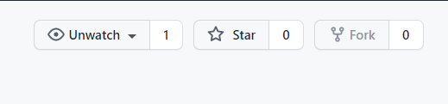

1. Then that repository will show under your account’s homepage. You could click the ‘your repositories’ button to see.

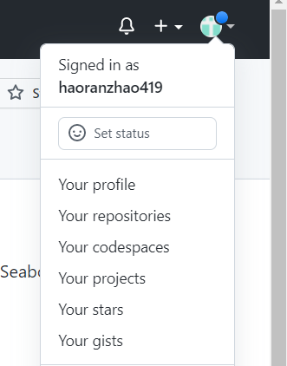

1. If you don’t set your name and email address please using the following codes to set that:

git config –global user.name “your-user-name”

git config –global user.email “your-email-address”

1. If you’ve already set that, using git clone to download that repository.
2. Going to the directory in that repository where you should upload your code, using: cd …/…/…
3. You could create a new folder using: mkdir your-directory-name (for example: mkdir 123456 )
4. git add your-directory-name (e.g.: git add 123456)
5. git status
6. git commit -m “…… ” (Describe your operation)
7. git status
8. git push -f origin master
9. Go to you GitHub account, and find the repository that you just forked.
10. Click the “Pull requests” button to create a new pull request, and in the new webpage, writing down some instruction and information about what your codes about.
11. Finally you could check whether your codes upload successfully or not in the original repository. And if it is your first time upload your code to this repository, you should sign your own CLA (Contributor License Agreement)